Experiment P: Buffer Solutions

Objectives
In this experiment, you will prepare a buffer solution according to provided specifications, and then investigate the buffering capabilities of this buffer solution.

Theory
Our blood is primarily buffered by the carbonic acid-hydrogen carbonate equilibrium which maintains the [H⁺] at approximately 5·10^{–8} mol/L, a pH of about 7.3. The addition of small quantities of strong acid or strong base leads to only small changes in pH compared to pure water. For example, the addition of 0.01 moles of base to a liter of blood causes a 0.1 pH change but a 5.0 pH change in pure water. Blood, along with several other body fluids, is said to be buffered. These buffered solutions resist changes in the hydronium ion concentration ([H⁺]) and when small quantities of strong acids or strong bases are added to them.
Buffers are important for several reasons:
- The pH of buffered solutions changes slightly on addition of small amounts of either hydronium or hydroxide ions. Maintaining a constant pH is vital in most biological systems and in many industrial applications.
- They allow us to prepare solutions of known pH quite simply.
Traditional buffers are solutions in which a weak acid and its conjugate base are both present in concentrations that are high when compared with the concentrations of [H⁺] or [OH–] being added. The mechanism by which buffer solutions resist changes in [H⁺] can be explained by Le Châtelier's Principle: the position of the acid-base equilibrium shifts in response to the stress caused by the added reagent.
HA(aq) ⇌ H⁺(aq) + A–(aq) (1)
When both HA and A– are added to water, equilibrium (1) is established. If H⁺ is added to this solution, the position of the equilibrium shifts to form more reactant, consuming most of the added H⁺. Therefore, no dramatic change in the pH is observed. Similarly, addition of OH– ion to the buffer solution shifts the position of the equilibrium to form more product, thus, consuming most of the added OH–. Again, no dramatic change in the pH is observed. This is the chemical principle that makes buffer solutions effective.
Given the equilibrium constant expression:
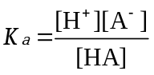 (2)

Rearrangement of (2) yields:
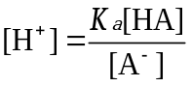 (3)
and taking the negative logarithm of both sides of (3) affords:
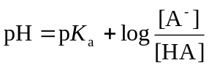 (4)
Equation (4) is commonly referred to as the Henderson-Hasselbalch equation, and is a general form of the relationship between pH, pK_{a}, [A⁻] and [HA] that can be applied to many weak conjugate acid-base pairs.
The Henderson-Hasselbalch equation is commonly used to calculate the pH of buffer solutions. By selecting the appropriate weak acid and its conjugate base and manipulating their concentrations, the pH of a solution can be buffered to any desired value within ± 1 pH of the pK_{a}.
Preparing a Buffer Solution
The Henderson-Hasselbalch provides us with a convenient way to determine in advance how to prepare a buffer solution to a desired pH and concentration. Although the buffer will contain a mixture of a weak conjugate acid/base pair (HA and A⁻ respectively) it is common in the preparation of a buffer solution to only directly dispense one of these two species, and to then add an appropriate amount of strong acid (if A⁻ had been dispensed first) or strong base (if HA had been dispensed first). For example, an acetic acid / acetate buffer can be prepared by weighing out a known amount of sodium acetate (the weak base), and then using hydrochloric acid to convert some of the sodium acetate into acetic acid (the weak acid), thereby creating a buffer.
The above description may be a bit dense, so what follows is the method we’ll be using laid out stepwise. To illustrate the process, let’s assume that we need to prepare a buffer solution from acetic acid (HA) and sodium acetate (A⁻). Further, let’s suppose that we require a final total buffer concentration of 0.200 mol/L, a final buffer volume of 100.00 mL, and a buffer pH of 5.25.
- Use the final target total buffer concentration and volume to calculate the amount of A⁻ or HA to begin with. In our buffer preparation, we’ll start by weighing out the conjugate base species (A⁻), sodium acetate. We will do this because in our example, the conjugate base is available in an inexpensive and easily-handled solid form: sodium acetate trihydrate (CH₃COONa•3H₂O, molar mass = 136.08 g/mol). But how much do we need? Keep in mind that, because of the way we’ll be making up our buffer, all of the A⁻ and HA that’ll be present in the buffer will originate from this initial amount of A⁻. Thus, to calculate how much A⁻ to weigh out at the start, we need to know how much total A⁻ and HA is present in the final buffer. We’ll calculate this from the final buffer concentration and volume.
and thus
Note that we convert volume to L
- Use the molar mass of the source of A⁻ to determine the mass of this material to weigh out. In our example, we are using sodium acetate trihydrate (CH₃COONa•3H₂O, molar mass = 136.08 g/mol) as our source of A⁻. Since each formula unit of sodium acetate trihydrate contains one unit of A⁻, we can calculate:

- Determine the number of moles of strong acid (HCl) that must be added to the initial amount of A⁻ weighed out, in order to create a buffer with the correct pH. This is the most mathematically complicated part of the process: we’ll use the Henderson-Hasselbalch equation (4) to determine this.
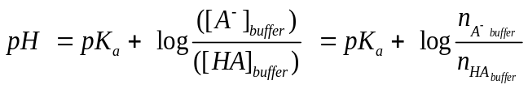
The desired pH is specified as 5.25. The pK_{a} for acetic acid (HA) is 4.76: this pK_{a} can be looked up directly from a trusted chemical information source, or can be calculated from the tabulated K_{a} value, as pK_{a} = -log (K_{a}). So:
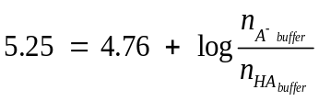 and thus
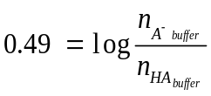
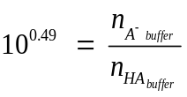
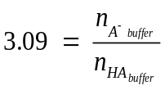
To solve for n_{HA buffer} we need to account for the fact that the hydrochloric acid we add to the 2.72 g of A⁻ we have weighed out will convert some of that A⁻ into HA:

HCl(aq) + A–(aq) → HA(aq) + Cl–(aq)

However, as we noted above in step 1, the total amount of A⁻ and HA present at all times will always equal the amount of A⁻ initially present:
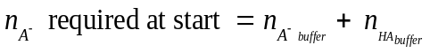, so
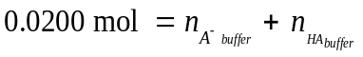(calculated above in step 1).
Thus, we now have two independent equations that describe the relationship between n_{A- buffer} and n_{HA buffer}:
and

From the known total amount of buffer (Step 1 above)
From the Henderson-Hasselbalch equation, the target pH, and the pK_{a} of acetic acid

To solve for the final buffer values for n_{HA buffer} and n_{A- buffer} we can simply algebraically rearrange one of these equations and then substitute it into the other. One way to do this is to rearrange the right-hand equation above to:
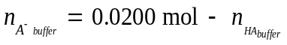
Then, we substitute this expression for n_{A- buffer} into the left-hand equation at the top of this page to get:
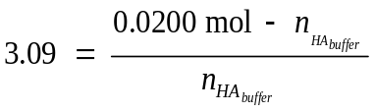
Finally, we can solve for n_{HA buffer:}
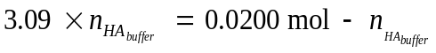
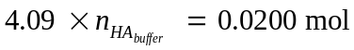
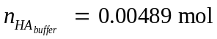
Since the final buffer should therefore contain 0.00489 mol of HA, we can now recognize that 0.00489 mol of hydrochloric acid will need to be added to our initial amount of A⁻ in order to convert 0.00489 mol of A⁻ into HA.

- Determine the volume of strong acid (HCl) of a given concentration that must be added to the initial amount of A⁻ weighed out, in order to create a buffer with the correct pH. The volume of HCl required will be dependent on the number of moles of HCl required (calculated in Step 3) as well as the concentration of the HCl that has been provided. In Experiment P, you will be using 0.500 mol/L HCl, so we’ll use this concentration for this example as well. Thus:
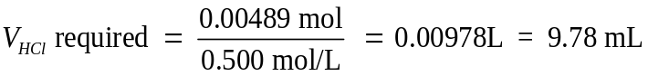

Based on the above work, one could plan out a preparation of the required buffer solution:
- Weigh 2.72 g of sodium acetate trihydrate into a small beaker. Then, quantitatively transfer this solid into a 100 mL volumetric flask using a small funnel and small portions of water to rinse and dissolve the sodium acetate trihydrate.
- Use a burette to dispense 9.78 mL of 0.500 mol/L HCl into the volumetric flask. This will adjust the buffer pH to the specified value of 5.25
- Fill the volumetric flask to the mark with deionized water. This will adjust the total buffer concentration to the specified 0.200 mol/L.
Additional Example (for Practice):
Suppose you want to make 50.00 mL of an acetic acid / sodium acetate buffer, with a pH of 4.80, using sodium acetate trihydrate and HCl (0.500 mol/L). Suppose also that you require the total concentration of buffer to be 0.200 mol/L.
- Calculate the amount (mol) of sodium acetate required to prepare 50.00 mL of a 0.200 mol/L solution. This will ultimately determine the total moles of buffer. Answer: 0.0100 mol
- Calculate the mass of sodium acetate trihydrate (CH₃COONa•3H₂O) required to make the solution described in Question 1 above. Answer: 1.36 g
- What is the pKa of the conjugate acid of sodium acetate? Answer: 4.76
- Calculate the amount (in moles) of HCl that must be added to the sodium acetate trihydrate to adjust the pH to 4.80. Answer: 0.00477 mol
- What volume of the HCl (0.500 mol/L) must be added to the sodium acetate trihydrate to adjust the pH to 4.80? Answer: 9.54 mL
Buffer capacity
A buffer cannot maintain the pH of a solution when relatively large amounts of acid or base are added. A buffer’s capacity refers to the amount of strong acid or strong base that a buffer can neutralize before its pH changes appreciably. “Appreciable” depends strongly upon the situation: A ΔpH of 1 unit is appreciable in most chemical and industrial systems; a ΔpH of 0.2 is appreciable in biological systems. The acid capacity of a buffer (amount of acid that a buffer can absorb before its pH changes by one unit) is not necessarily equal to the buffer’s base capacity (amount of base that a buffer can absorb before its pH changes by one unit). When the weak acid and base concentration are equal, the acid and base buffering capacities are equal.
Buffer capacity may be calculated using the following formulae:

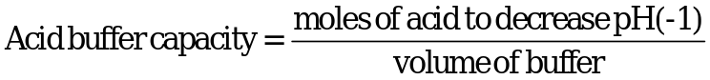 (6)

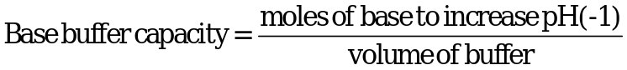 (7)

The action of a buffer solution is visible in the titration curve of a weak acid and a strong base. In the following figure, the pH changes only by about 0.2 between the addition of 5 and 20 mL of 0.50 mol/L OH–. In this region, the solution in the titration flask is a buffer solution.

Practical Considerations
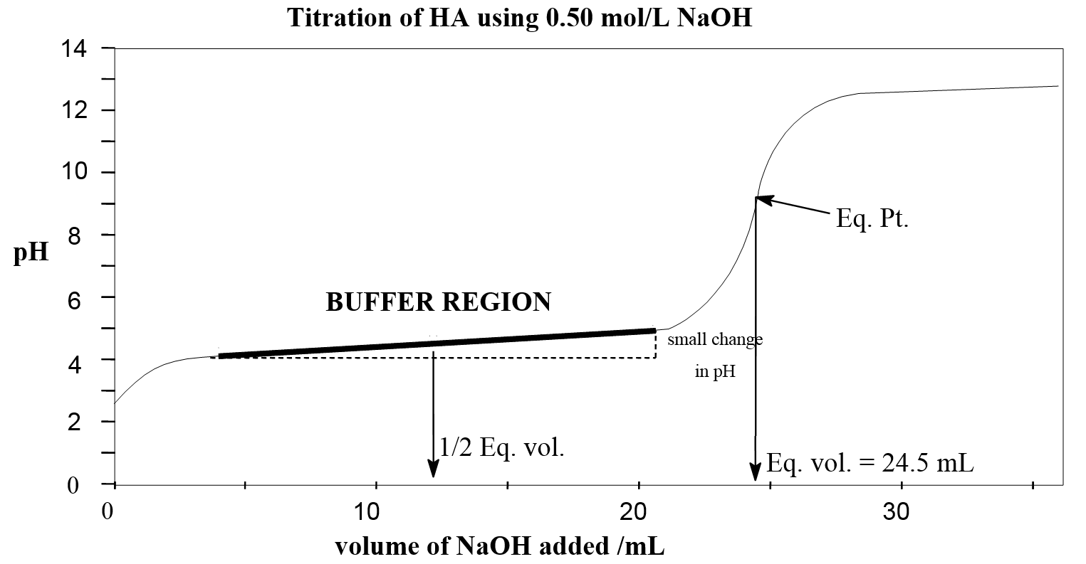
There are a number of commercially available buffer solutions, and often the simplest and/or most economical way to obtain a buffer solution with a suitable pH from a chemical supplier and then dispense and dilute it to the required specifications. However, it is also common and convenient to prepare buffer solutions directly by preparing a solution of the conjugate acid/based pair in the correct ration, and then diluting the resulting buffer to the desired final concentration. In this experiment, you will be assigned (via an online BlackBoard prelab) a target buffer pH and total buffer concentration. Before arriving at the lab, you will calculate the amount of A- and HA you will be using: A- will be weighed out as a solid (gravimetrically) and HA will then be added as a solution (volumetrically).

Experimental Method
An acetic acid acetate buffer system will be prepared and tested to determine the effects addition of a strong acid and a strong base on the buffer system. The effect of these additions will be monitored by observing any changes in the pH of the solution. The prepared buffer will be diluted and the effect of adding strong acid and strong base to the diluted buffer and to a commercial buffer will also be studied.

Advance Study Assignment
1. Review the previous information on acid-base chemistry.
2. Review instructions on the use of pH meters (see introduction).
3. What equation might you use to find the ratio of the concentration of the acid to that of its conjugate base at various pH values? Answer: the Henderson-Hasselbalch equation
4. What volume of 0.250 mol/L Ca(CH₃COO)₂ (calcium acetate) solution should you add to 25.00 mL of 0.500 mol/L CH₃COOH to prepare a buffer solution which has a pH of 4.754? Answer: 25.0 mL.
5. Use the Henderson-Hasselbalch equation to calculate the pH of a buffer solution (to the correct number of significant figures) in which the concentration of the benzoate ion is 0.0300 mol/L, and the concentration of the benzoic acid is 0.0100 mol/L. Answer: 4.670.
6. Calculate the mass of sodium acetate trihydrate (CH₃COONa•3H₂O) required to make 50.0 mL of a 0.20 mol/L solution. Answer: 1.36 g

Reagents and Equipment
- sodium acetate trihydrate | - 0.500 mol/L HCl
- LabQuest 2 unit and pH electrode | - burettes (2)
- 0.1 mol/L HCl | - 50 mL and 150 mL beakers
- 0.1 mol/L NaOH | - deionized water
- 50 mL or 100 mL graduated cylinder | - 100 mL volumetric flask
- pH 4 and pH 7 standard buffers for pH electrode calibration

Prelaboratory Assignment

You must complete an online assignment before coming to the lab. The assignment will involve determining the amounts of acid and base needed to prepare a specific buffer solution. As you complete the assignment, be sure to copy your responses to page P-17, as you’ll be using these values in the actual experiment.

Procedure
For this experiment, students will work in pairs. Each student will have completed a pre-lab independently, and in the event that the partnered students had different prelab buffer specifications, the partners are free to choose which buffer to actually prepare.
Calibrate your pH meter following the appropriate instructions given on page 21 of the introductory section of this manual.

Preparation of burettes
Using the correct technique, rinse one burette three times with 5 mL aliquots of the 0.1 mol/L HCl solution. Fill the burette to a point above the 20 mL (do not set this value to 0.00 mL).
Prepare a second burette, but with the sodium hydroxide solution.

Part I: Preparation of the acetic acid acetate buffer solution
You will use the values calculated in the online prelaboratory assignment. If each partner had a different prelab (and thus different values), simply choose one of the two buffers at your discretion for this partnered work.
- Into a small (25 or 50 mL) dry beaker, accurately weigh out the correct mass of sodium acetate trihydrate, as calculated in your prelab assignment. Don’t be concerned if your mass is not exactly the same as calculated: any mass within 0.02 g of the calculated value will suffice.
- Quantitatively transfer the sodium acetate trihydrate into a 100.00 mL volumetric flask. Use small portions of deionized water to rinse all the sodium acetate trihydrate into the flask.
- At one of the common 0.500 mol/L HCl dispensing burette stations, transfer the appropriate volume (from the prelab) of the hydrochloric acid to the volumetric flask.
- Use deionized water to fill the volumetric flask. Stopper the flask and invert it about 20 times to ensure complete dissolution and mixing of the flask contents. For the remainder of the experiment, this solution will be described as your prepared buffer.

Part II: Effect of the addition of a strong acid to deionized water
- Measure the pH of 20 mL of deionized water (with a trace of NaCl so that the solution conducts) in a 50 mL beaker.
- Add 2 drops of HCl from a burette to the water and again measure the pH.

Part III: Study of the prepared buffer solution – determination of buffering capacity

Effect of addition of HCl
1. Dispense 20 mL of the prepared acetate buffer into a beaker and record the pH. Add HCl from a burette until the pH changes one full pH unit. Add the acid slowly with constant stirring (use a plastic rod for this!!!) and monitoring the pH change continuously. Record the final pH and the volume dispensed to determine the amount of HCl required to decrease the pH by one pH unit.
2. Continue to add HCl until a second full pH unit change occurs. This change will require a much smaller volume of HCl, so add the HCl carefully. If you overshoot the desired pH, do not repeat the procedure, simply record the volume and pH attained.

Effect of addition of NaOH
3. Repeat step 1, using NaOH as the titrant.
4. Repeat step 2, using NaOH as the titrant.

Part IV: Preparation and study of the diluted buffer solution
1. Mix 80.0 mL of deionized water and 20 mL of buffer in a beaker. This creates 100 mL of a new, more dilute, buffer. You may use graduated cylinders for this step: high accuracy is not necessary here.
2. Repeat the analysis in part III with 20 mL aliquots of the diluted buffer. You may use a 50 mL graduated cylinder to measure out these 20 mL portions.
- Determine the volume of acid required for ΔpH = –1 and –2.
- Determine the volume of base required for ΔpH = +1 and +2.

When you have finished all your titrations, and have disposed of all of the wastes properly, wash your burettes with hot tap water (four times) and rinse once with deionized water. Leave them at your workstation empty and upside down.
It is important that the pH electrode is washed and stored in the storage buffer.

Before leaving the laboratory, check that all your equipment is clean and returned to the correct location: complete the sign-out checklist on page P-18 and have it signed by your lab instructor.
Remember to have your Observation Sheet(s) checked and signed by your laboratory instructor before leaving.

Assessment and report:
Experiments O and P will be assessed together (20 points total) as follows:
Written report (8 points): The data gathered as part of Experiments O and P will be used to complete the lab report following Experiment P (starting on page P-17). This lab report will encompass the Experiments O and P combined, but does mostly focus on Experiment O. The written report is due at the start of Experiment Q.
Online Quiz (10 points): The material covered in Experiments O and P will be subject to a quiz at the start of Experiment Q. The quiz will be administered online via BlackBoard, so you are strongly encouraged to bring your laptop, tablet, or other device to complete the quiz. To prepare for the quiz, you are encouraged to:
- Complete the practice questions on pages P-11 to P-16.
- Complete the practice online quiz, available on BlackBoard. Note that this practice online quiz is much longer than the actual online quiz you will write for credit.
Titration analysis results (2 points): The titration data for the determination of the acid content of vinegar (Experiment O, Part B, page O-13) will be assessed for accuracy by comparison to the actual value. Your data (page O-13) must be entered into a Google Form at: https://goo.gl/PGUuMj. The form may also be accessed via BlackBoard and should be entered before leaving the lab.

Practice Questions: Buffer Solutions
Note: the for-credit lab report following Experiment P will cover both Experiment O and Experiment P, but will focus on Experiment O. The for-credit written lab report (for submission and grading) begins on page P-17.

Acetic acid - sodium acetate buffer solutions
1. Draw a schematic plot of a pH titration curve and identify the buffer region and the point with the highest buffering capacity. Explain the function of a buffer and the reason for selecting the above point.

2. Compare the pH of the original prepared buffer solution and the 1/5 diluted buffer solution. Using the K_{a} relation or the Henderson-Hasselbalch equation, explain why the change in pH was so small compared to the change in buffer concentration.

3. a) What was the change in pH when 2 drops of HCl was added to the water (Part II)?

b) Fill in the following Table.
Buffer | Initial pH | pH change | volume HCl required (mL) | volume NaOH required (mL)
prepared buffer |  | first pH unit
prepared buffer |  | second pH unit
dilute buffer |  | first pH unit
dilute buffer |  | second pH unit

c) Use the weak acid dissociation equilibrium and LeChâtelier’s Principle to explain the effect of adding H⁺ (in the form of the strong acid HCl) to the buffer solution.
i) For the 1st pH unit change.

ii) For the 2nd pH unit change.

d) Use the weak acid dissociation equilibrium and LeChâtelier’s Principle to explain the effect of adding OH– (in the form of the strong base NaOH) to the buffer solution.
i) For the 1st pH unit change.

ii) For the 2nd pH unit change.

Capacity of the buffer solutions
1. a) Determine the acid and base buffer capacities of each HA and A– (in mol L^{–1}) of:
i) the buffer solution.

ii) the dilute buffer solution.

ii) the commercial pH 7.00 buffer solution.

b) Use the above information to explain why it is important that the pH electrode be washed well with deionized water before it is placed into the standard buffer solutions. (Assume that each bottle of buffer solution contains 50 mL of commercial buffer.)

2. Comment on the differences in buffering capacity of the original buffer and the diluted buffer. Should they be nearly the same or very different? Explain.

3. Did your prepared buffer solution exhibit a higher buffer capacity against acid, or base? Consider the pH titration curve for acetic acid – sodium acetate buffer, paying special attention to where the pH of your buffer solution lies on the curve, relative to the pK_{a} of acetic acid. Does it make sense that your buffer should exhibit a higher buffering capacity against either acid or base?

4. A 1.00 mol/L solution of an unknown monoprotic acid is titrated with NaOH. When 85.0 % of this weak acid has reacted, the pH of the resulting solution at equilibrium is 5.33. Determine the K_{a} for this weak acid.

5. You wish to buffer a solution at pH 1.26. If equal amounts of the acid and conjugate base are used, what is the best choice for the acid – conjugate base pair? (Use only the acids on your data sheet).

- Calculate the volume of 0.25 mol/L sodium dihydrogen phosphate that must be added to 150 mL of 0.50 mol/L sodium hydrogen phosphate to prepare a buffer solution of pH 7.400.

- If the buffer in question 1 is diluted by a factor of 10, should its pH remain approximately equal to 7.400, become significantly greater than 7.400, or become significantly less than 7.400? Explain your choice.

Observation Sheet: Buffer Solutions
Assessment
Experiments O & P
Report /8
Quiz /10
Data /2
Total /20

From your Prelab:
Assigned final target buffer pH: _5.25___________

Assigned final target total buffer concentration: 0.200 mol/L________

Calculated mass of sodium acetate trihydrate
to weigh out (Prelab Question 3): ____2.72 g________

Calculated volume of 0.500 M hydrochloric
acid to dispense (Prelab Question 5): __9.78 mL_______

Part I: Buffer preparation
Mass of sodium acetate trihydrate: | _2.72 g___________
Volume of 0.500 M HCl(aq) dispensed: | ___9.78 mL_________

Part II: Effect of the addition of a strong acid to deionized water
pH of deionized water: | ____6.37________
pH of deionized water after the  addition of 2 drops of 0.10 mol/L HCl: | ____3.28________

Student: (name)___________________________ (signature)_______________________________________________
Instructor: (signature)____________________ Bench # ______ Laboratory Section: ______
CHEM 102: Buffer Solutions Sign-out Checklist

Equipment Cleaned and returned to Common Glassware Drawer | Initials
Graduated Cylinder(s)
50 mL Beaker
100 mL Beaker
150mL Beaker
400 mL Beaker
Equipment Left on Student Bench | Initials
Lab Quest
pH Electrode
pH 4 & 7 Buffers
0.1M NaOH Squeeze bottle
0.1M HCl Squeeze bottle
Equipment Returned to Side bench | Initials
Buret
Retort Stand
Meniscus card reader
Equipment Returned to Chem 102 Special Issue Glassware Drawer | Initials
100 mL Volumetric Flask
Other Cleaning and/or Upkeep | Initials
Bench wiped with a damp paper towel
Sinks clear of broken/dirty glassware
Water bottles returned to end of bench
Student: (name)___________________________ (signature)_______________________________________________
Instructor: (signature)____________________ Bench # ______ Laboratory Section: ______

Parts III and IV: Effect of addition of strong acid and strong base to buffer solutions
[HCl] _____0.100_____ mol/L [NaOH] _______0.100_____ mol/L
 |  | Part III:  Prepared buffer | Part IV:  Diluted buffer
first pH change  Addition  of HCl  second pH change | initial pH | 4.57 | 4.56
first pH change  Addition  of HCl  second pH change | final burette reading | 29.19 mL | 19.47 mL
first pH change  Addition  of HCl  second pH change | initial burette reading | 19.06 mL | 17.35mL
first pH change  Addition  of HCl  second pH change | volume added | 10.13 mL | 2.012mL
first pH change  Addition  of HCl  second pH change | final pH (first unit change) | 3.6 | 3.53
first pH change  Addition  of HCl  second pH change | final burette reading | 32.85 mL | 20.47 mL
first pH change  Addition  of HCl  second pH change | initial burette reading | 29.19 mL | 19.47 mL
first pH change  Addition  of HCl  second pH change | volume added | 3.66 mL | 1.00 mL
first pH change  Addition  of HCl  second pH change | final pH  (second unit change) | 2.63 | 2.56
First pH change  Addition  of NaOH  second pH change | initial pH | 4.55 | 4.58
First pH change  Addition  of NaOH  second pH change | final burette reading | 21.80 mL | 16.61 mL
First pH change  Addition  of NaOH  second pH change | initial burette reading | 11.43 mL | 14.65 mL
First pH change  Addition  of NaOH  second pH change | volume added | 10.37 mL | 1.96 mL
First pH change  Addition  of NaOH  second pH change | final pH (first unit change) | 5.55 | 5.55
First pH change  Addition  of NaOH  second pH change | final burette reading | 25.44 mL | 17.31 mL
First pH change  Addition  of NaOH  second pH change | initial burette reading | 21.80 mL | 16.61 mL
First pH change  Addition  of NaOH  second pH change | volume added | 3.64 mL | 0.70 mL
First pH change  Addition  of NaOH  second pH change | final pH  (second unit change) | 6.55 | 6.58

Student: (name)___________________________ (signature)_______________________________________________
Instructor: (signature)____________________ Bench # ______ Laboratory Section: ______

Report: Experiment O (pH Titration Curves) & Experiment P (Buffer Solutions)
Assessment
Experiments O & P
Report /8
Quiz /10
Data /2
Total /20
Name: ____________________________ Bench #______
Section: ___________ Date: ________________________
Laboratory Instructor: __________________________
Online Components (These are assessed in addition to the written report and are included here as a reminder):
- Experiment O Part B Titration Data (via Google Forms): Enter the titration runs YOU wish to be graded on into the Google Form – link available on the Chemistry 102 Lab BlackBoard site and here: https://goo.gl/PGUuMj.

Exp. O & P Online Quiz: You will complete the online quiz for Experiments O and P at the beginning of Experiment Q. Please bring your own laptop or other device to write this quiz.
For all following questions, calculations must be shown with the correct units and number of significant figures.

Experiment O Part A: pH Meter Titration of a Strong Acid with a Strong Base
Stock concentration of NaOH(aq): 0.0999 mol/L Volume of HCl(aq): 20.00 mL_

- Based on your results from the pH meter titration, prepare a graph of pH versus Volume of NaOH(aq) for Experiment O: Part A. You should use spreadsheet software to prepare the graph, add a hand-drawn smooth line of best-fit, and attach a hardcopy of the graph with this report. The graph should be printed alone on the page, separate from the original data, and the graph should take up the entire page of paper. (1.0)

- Clearly indicate on the graph from question 1 the pH range where
  - the indicator changes color. (0.25)
  - the pH is changing most rapidly. (0.25)

- Clearly indicate on the graph from question 1 how to obtain the following values:
  - the pH at the equivalence point. (0.25).
pH = 5.25 (from the graph)
  - the volume of added titrant at the equivalence point. (0.25)
Volume = 18.07 mL (from the graph)

- Based on your answer to 3b., calculate the number of moles of NaOH(aq) required to fully react with the stock acid solution used in the pH titration. (0.5)

0.0999 moles = 1000 mL
? = 18.07 mL
(18.07 x 0.0999)/1000
= 0.001805 moles
- Based on your answer to question 4, calculate the concentration of the stock acid solution used in the pH titration. (0.5)

Mole ratio, NaOH : HCl = 1 : 1
Moles of HCl = Moles of NaOH = 0.001805 moles
Concentration = $\frac{moles}{volume } x 1000 mL$ = $\frac{0.001805}{20.0}$ x 1000 mL = 0.09025 M

- Calculate the number of moles of chloride ion in the solution at the equivalence point of the pH titration. (0.5).

½ of 0.001805 = 0.0009025 moles

- Calculate the concentration of the chloride ion at the equivalence point of the pH titration. (0.5)
pH = pKa + log $\frac{[{Cl}^{-}]}{[HCl]}$
5.25 = 4.6 + log $\frac{[{Cl}^{-}]}{0.09025}$
5.25 – 4.6 = log $\frac{[{Cl}^{-}]}{0.09025}$
0.65 = log $\frac{[{Cl}^{-}]}{0.09025}$
0.65 = log $[{Cl}^{-}]$ – log 0.09025
log $[{Cl}^{-}]$ = 0.65 + log 0.09025
log $[{Cl}^{-}]$ = -0.3946
$[{Cl}^{-}]$ = 0.403

Exp. O Part B: Indicator Titration of Vinegar
Titrant: ________________________________ Stock titrant concentration: _______________
Dilution: The ____________________________ was diluted: _____________ mL to _____________ mL
Volume of NaOH added (mL): 1st Acceptable Run:_34.29 mL_ 2nd Acceptable Run: _34.26 mL_

- Based on your results for the 1st Acceptable Run, calculate the molarity of your analyte (vinegar), assuming it is a monoprotic acid. Remember to account for any dilutions! (1.0)

M₁V₁ = M₂V₂
M₁ x 0.04 = 0.0999 x 0.03429=
M₁ = 0.08560 M

- Repeat the above calculation for your 2nd Acceptable Run (no need to show this calculation here). Record the values for the two acceptable runs and their average below. (0.5)
1st Acceptable Run: __0.08560 M_ 2nd Acceptable Run: __0.08556 M__ Average value: __0.08558 M_

- In each titration you performed in Part B of Exp O, you carefully pipetted 10.00 mL of analyte solution into an Erlenmeyer flask before the titration because it was important that this volume was known to a very high degree of precision and accuracy. If the Erlenmeyer flask was clean but still wet (on the inside) with deionized water before the 10.00 mL of analyte was placed in it, how would this effect the titration? (0.5)

M₁ = 0.08560 M
V₁ = 10.0 mL or 0.010 L
V₂ = 25.0 mL or 0.0250
M₂ = ?
M₁V₁ = M₂V₂
0.08560 x 0.010 = 0.0250 x M₂
M₂ = 0.03424 M
Volume of NaOH = 0.03424 x 0.025/0.0999 = 0.008569 L or 8.569 mL
Therefore, the volume required would be less than the volume in part B.

- Assuming a measured pH of 2.43 for your original analyte (vinegar before dilution) solution, calculate the percent dissociation of the acid. (1.0)

pH = -log[H⁺]
2.43 = -log[H⁺]
[H⁺] = antilog 2.43
[H⁺] = 0.0037 M
% dissociation = ([H⁺] x 100)/initial concentration
% dissociation = (0.0037 x 100)/0.1041 = 3.56%
- For your analyte (vinegar), indicate whether the pH at the equivalence point should be equal to 7.0, greater than 7.0, or less than 7.0. Explain your choice, including the appropriate balanced net ionic equation. (0.5)
At equivalence point or end point of a reaction, both neutralization and secondary reactions from the products occur. Neutralization reactions are straightforward. Secondary reactions continue due to water and unreacted acid. These make the conjugate base of the acid to act as a base, leading to increase in pH of the solution.
HA+NaOH⟶NaA+H2O
A⁻_{(aq)} + H₂O_{(l)} ⇌HA_{(aq)} + OH⁻_{(aq)}

- Use Le Châtelier’s Principle and the weak acid dissociation equilibrium to explain how the addition of NaOH will completely neutralize an unknown weak acid (HA) at the equivalence point in a titration. Hint: you need to consider that that the hydroxide ion reacts directly with H⁺ (or hydronium ion). (0.5)
At the equivalence point, all the HA has been titrated, and hence converted to its conjugate base A⁻. At the equivalence point, the acid concentration (HA) does not have a net increase as that of the base (NaOH), hence the pH increases.

A⁻_{(aq)} + H₂O_{(l)} ⇌HA_{(aq)} + OH⁻_{(aq)}

End of Report

